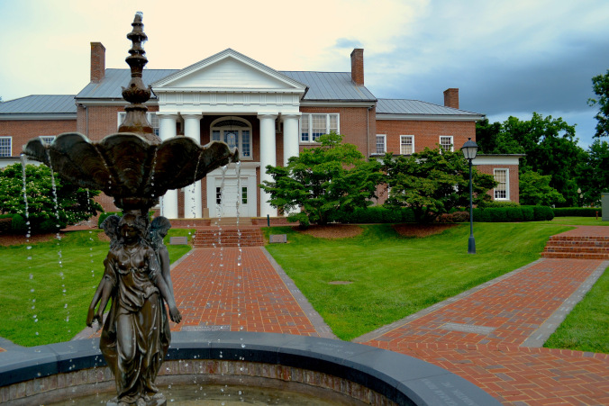

Founded in 1887, *The Cento* is the sole student newspaper for the Centre community. *The Cento* is **written and designed solely by Centre students** and is printed at the *Herald-Leader* in Lexington, KY with 1,500 copies for each issue.

Each year we **publish 10 issues** and distribute them to fourteen on-campus locations. These papers reach 1,381 students and around 500 members of the faculty and staff, many of who live in the Danville area.

# About The Cento

**SUBSCRIBE TO THE CENTO**

Centre College’s Student Newspaper www.cento.centre.edu  
cento@centre.edu

(xxx)yyy-yyyy

* Organization

NAME: _____________________________________________________________

STREET ADDRESS: ____________________________________________________

CITY, STATE, ZIP CODE: _______________________________________________

EMAIL ADDRESS: ____________________________________________________

PAYMENT METHOD (Check or Cash): _________________________________

CENTRE RELATION (Parent, Alumni, etc.): _____________________________

*Please address all checks to “The Cento.”*

*Mail to: The Cento, 600 West Walnut Street, Danville, KY 40422*

***Why should you subscribe to The Cento?***

A subscription to *The Cento* allows you to stay up to date with the latest news and events on Centre’s campus. For only $25, you can have every issue of The Cento delivered to your door. You can also sign-up for our email newsletter which highlights specific articles and provides links to our website and social media.

**Simply fill out the rest of this form for your own subscription!**

**Subscription Order Form**

Centre College’s Student Newspaper www.cento.centre.edu  
cento@centre.edu